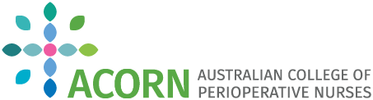
WESTERN AUSTRALIA

STUDY DAY

AT
St John of God Midland Public and Private Hospitals
22nd February 2020
0830-1300hrs

Lots of great topics
Difficult Intubation
Dr Tanya Strickland, Consultant Anaesthetist at Armadale Health Service

Cardiothoracic Sternal Wound Dressing
Mandy Collins, Clinical Nurse Specialist, Sir Charles Gairdner Hospital

Vascular contribution to wound management
Dr Kishore Sieunarine, Consultant Surgeon

Orthopaedic Trauma from a Nursing perspective
Tim Kelsey, Product Consultant, DePuy Synthes.

Trade displays on wound care and negative pressure dressing
FEE’s
Members $10
Non-Members $50
Registration & payment at www.acornwa.org.au

